VERSION 1 - For Users NOT using SSO (For SSO users see Version 2 below)

We are excited to announce a tool to help with our return to the office. You will now be able to reserve a desk through Kadence. This is a simple to use tool which lets you coordinate your time in the office by letting you see when your team members and colleagues are coming to the office, where they will be sitting, and then letting you reserve an available desk nearby.

You will receive an email from no-reply@onkadence.co before <REPLACE WITH THE GO LIVE DATE> asking you to create a password. It will look like the example below. If you have not received this email before <REPLACE WITH THE GO LIVE DATE> please check your junk folder.
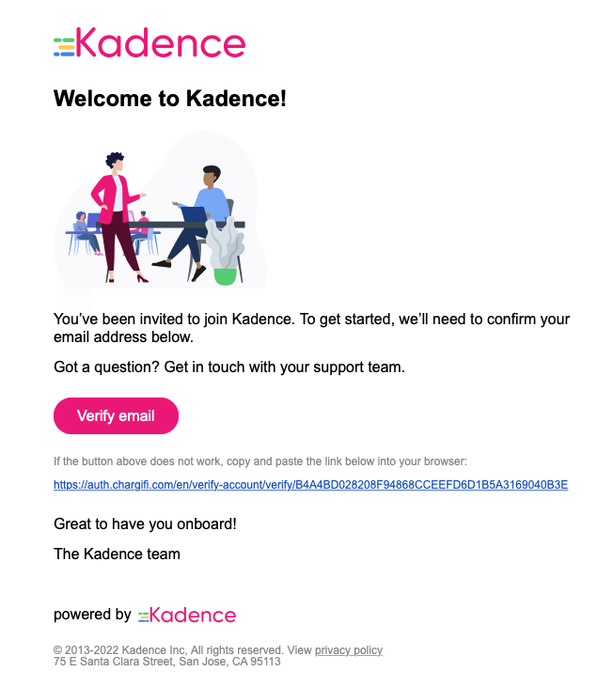

The link will open in your browser and ask you to create a password, and then you can login with your new credentials, which is your email as the username and the password you just created.

We also highly recommend downloading the mobile app (use the links if you are reading this on your phone; if you are reading this on your computer simply scan the QR code with your phone).



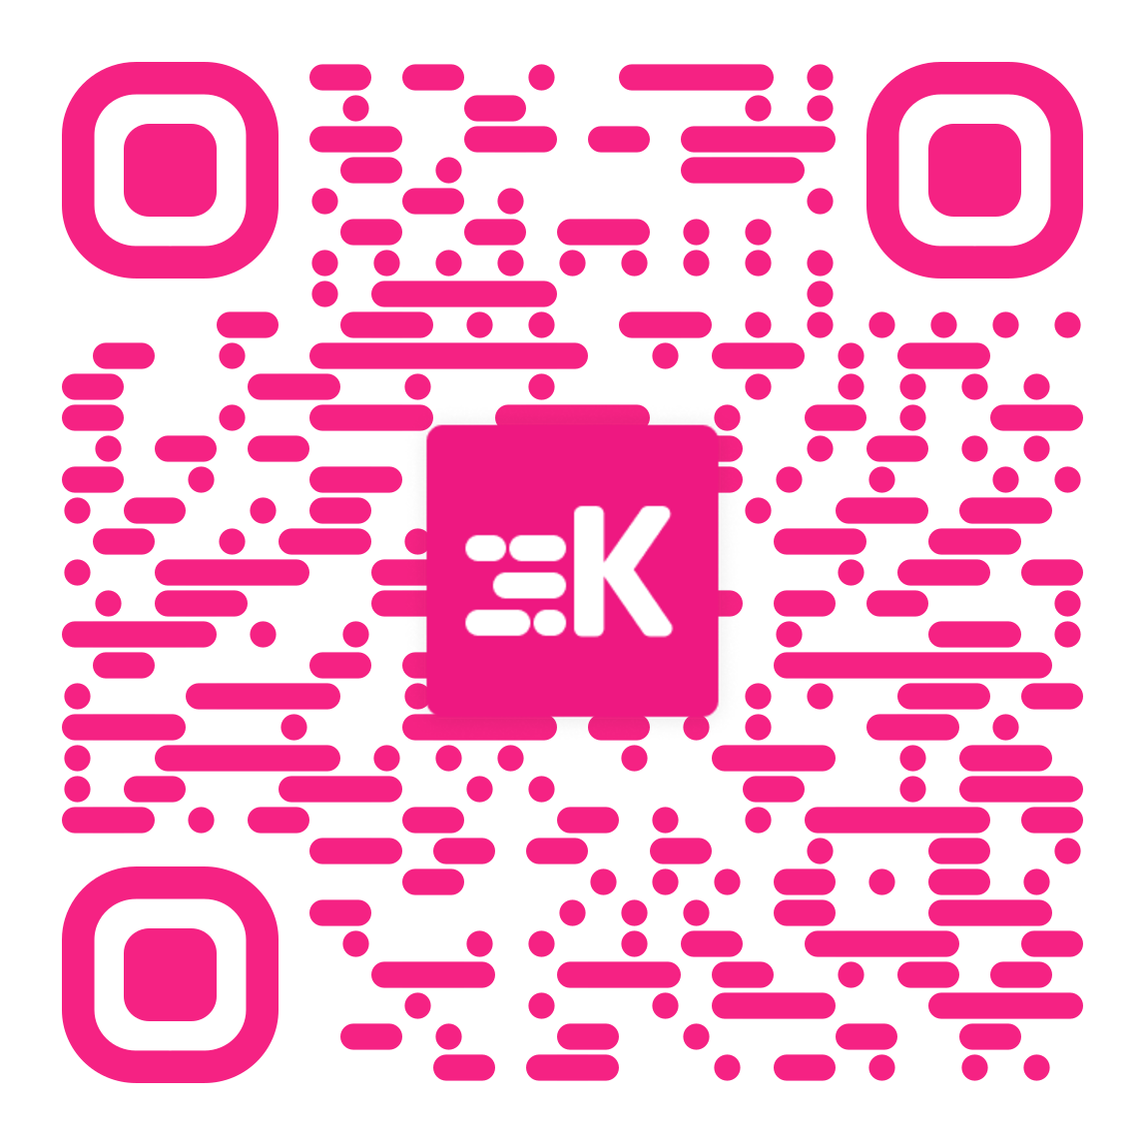

Once you have downloaded the mobile app and opened it you will sign in with your new credentials and you are all set. This short training video will show you how easy it is to use the Kadence mobile app, and how to customize your profile and settings.

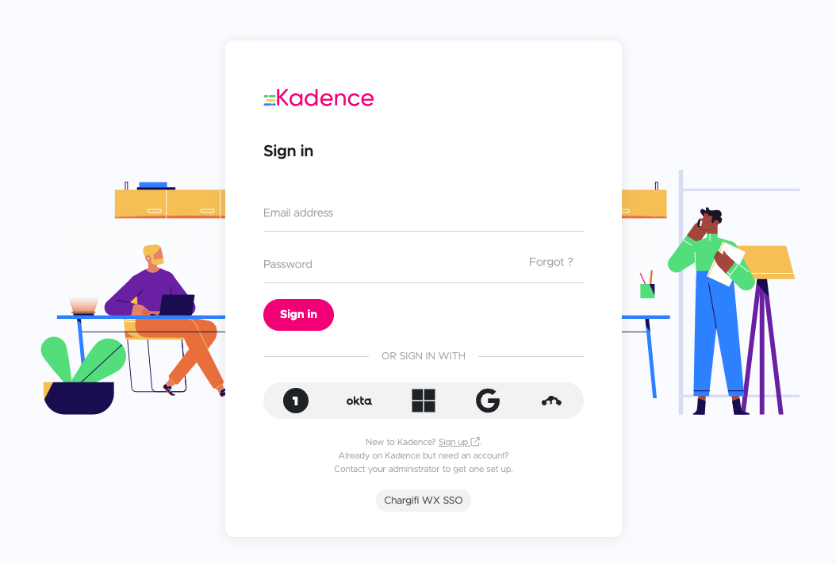

You can also book using the web app found at login.onkadence.co and sign in with the same credentials, and this training video will walk you through using the web app.

Your favorite place to use Kadence will likely be in <Teams / Slack>.

This online Getting Started Guide will give you additional information you might find useful.

We are so excited to take this next step in our hybrid work journey. We’re happy to be able to provide tools like Kadence to help you coordinate with your teams and friends to be in the office when it offers the best value, and provide the wellness benefits of being in the same physical space.

VERSION 2 - Users signing in with SSO (without blocking the welcome email):

We are excited to announce a tool to help with our return to the office. You will now be able to reserve a desk through Kadence. This is a simple to use tool which lets you coordinate your time in the office by letting you see when your team members and colleagues are coming to the office, where they will be sitting, and then letting you reserve an available desk nearby.

You will receive an email from no-reply@onkadence.co before <REPLACE WITH THE GO LIVE DATE> asking you to create a password. It will look like the example below.

You do not need to do anything with this email. All you need to do is download the app (use the links if you are reading this on your phone; if you are reading this on your computer simply scan the QR code with your phone).

Once you have downloaded the mobile app and opened it, use your <REPLACE WITH YOUR SSO PROVIDER (GOOGLE, O365, OKTA, etc.)> login credentials by tapping the icon as shown below. This short training video will show you how easy it is to use the Kadence mobile app, and how to customize your profile and settings.

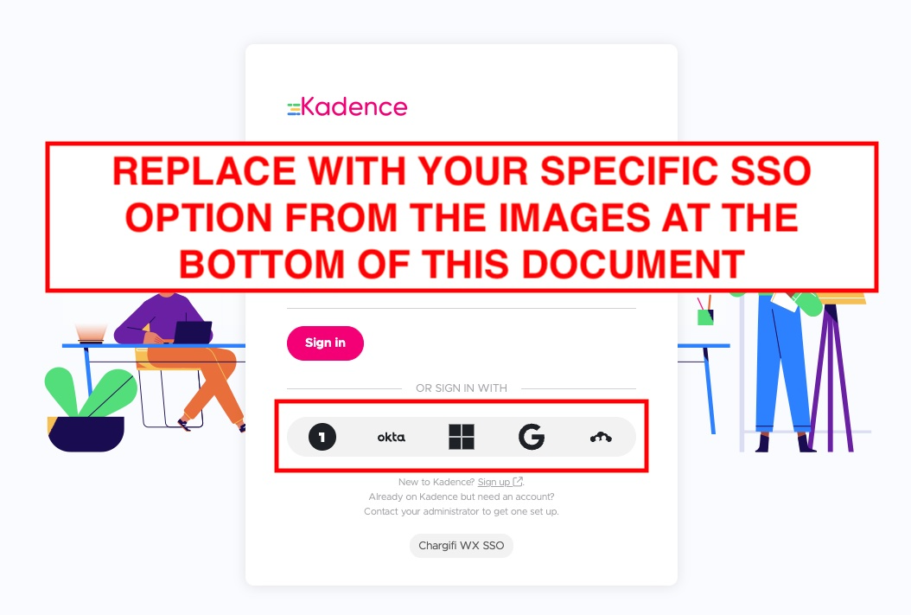

You can also book using the web app found at login.onkadence.co and sign in with the same credentials, and this training video will walk you through using the web app.

Your favorite place to use Kadence will likely be in <Teams / Slack>.

This online Getting Started Guide will give you additional information you might find useful.

We are so excited to take this next step in our hybrid work journey. We’re happy to be able to provide tools like Kadence to help you coordinate with your teams and friends to be in the office when it offers the best value, and provide the wellness benefits of being in the same physical space.

VERSION 3 - Users signing in with SSO (blocking the welcome email):

We are excited to announce a tool to help with our return to the office. You will now be able to reserve a desk through Kadence. This is a simple to use tool which lets you coordinate your time in the office by letting you see when your team members and colleagues are coming to the office, where they will be sitting, and then letting you reserve an available desk nearby.

All you need to do is download the app (use the links if you are reading this on your phone; if you are reading this on your computer simply scan the QR code with your phone).

Once you have downloaded the mobile app and opened it, use your <REPLACE WITH YOUR SSO PROVIDER (GOOGLE, O365, OKTA, etc.)> login credentials by tapping the icon as shown below. This short training video will show you how easy it is to use the Kadence mobile app, and how to customize your profile and settings.

You can also book using the web app found at login.onkadence.co and sign in with the same credentials, and this training video will walk you through using the web app.

Your favorite place to use Kadence will likely be in <Teams / Slack>.

This online Getting Started Guide will give you additional information you might find useful.

We are so excited to take this next step in our hybrid work journey. We’re happy to be able to provide tools like Kadence to help you coordinate with your teams and friends to be in the office when it offers the best value, and provide the wellness benefits of being in the same physical space.

Specific SSO Login Screens
